Two software :  
prothues 8.13

Arduino ide – [Software | Arduino](https://www.arduino.cc/en/software)

Pratical -3

Step 1: - Install proteus on your system.

Step 2: - To add Arduino to Proteus we need to add libraries for Arduino

Go to following Link <https://github.com/Proteus-LIBRARY/Arduino-Library>

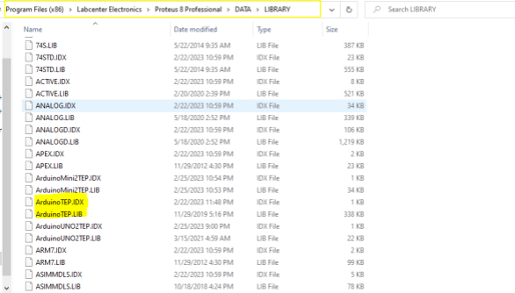

Component-

1. Arduino uno - 4

2. MOTOR-PWMSERVO – 2 (middle)

3. GROUND - 3

4. POWER - 1

Practical – 4